University of New Brunswick
Faculty of Engineering


ECE 2215
Final Project Report
December 3rd, 2024

Adam Bateman 3753751 (25%)

Ahmed Hessein Hassona 3772324 (25%)

Alexander Ross 3752371 (25%)

Corey White 3759566 (25%)

Introduction
The project task is to create a modulo 2345 counter with respect to a radix Y. In our case, our radix Y is 14. This counter must have functionalities allowing it to swap between radix Y and X as an output, as well as being capable of counting both up and down. The counter must be able to accept a load value only if it is less than the max value allowed and have a switch to enable/disable the counter. The load value will be displayed to the red LEDs in binary, and the output is sent to the 7-segment displays in the radix selected. The green LED’s will display the counting value of the lowest 8 bits.

Radix
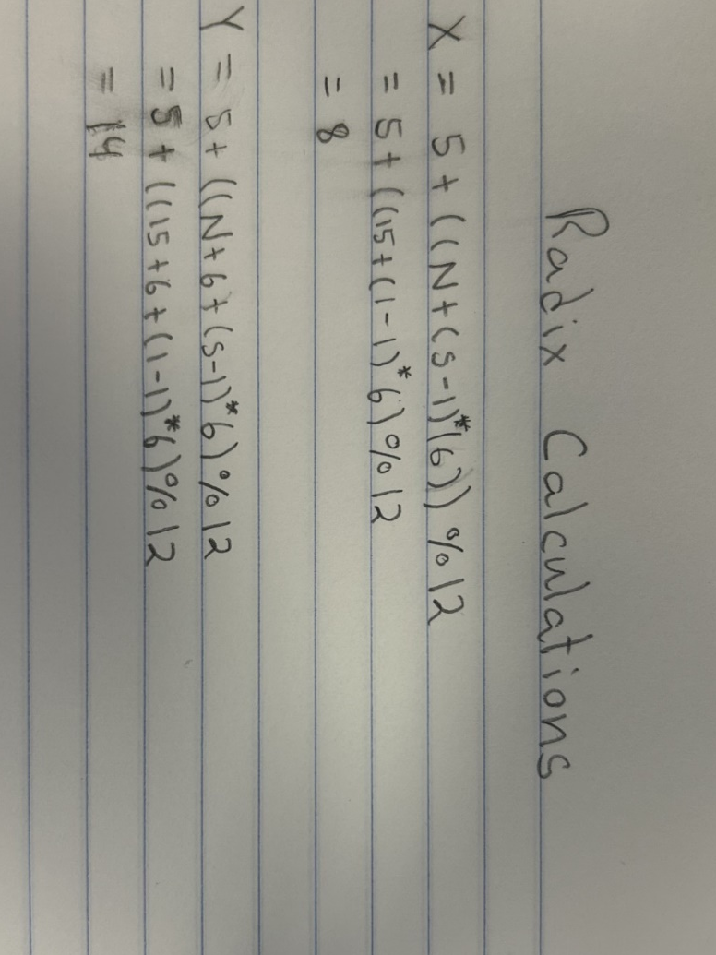

Design
Top Level Entity Code:
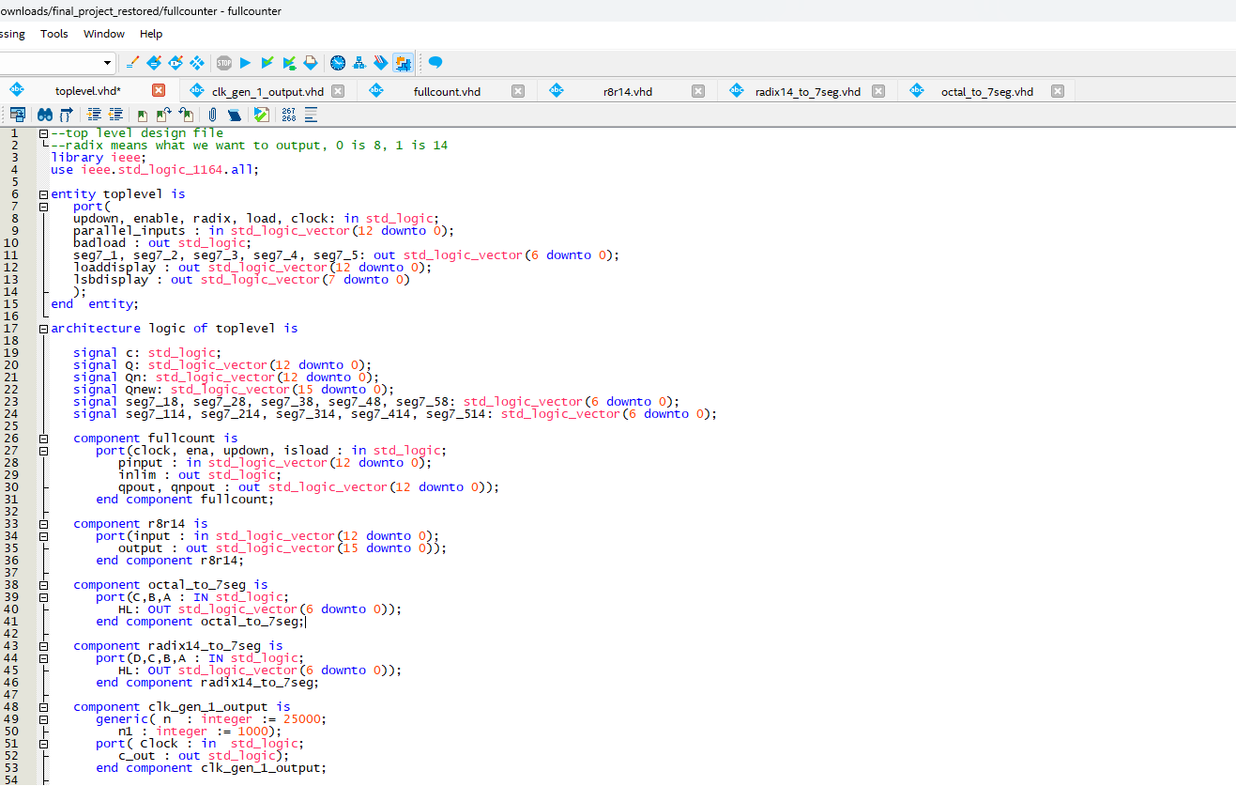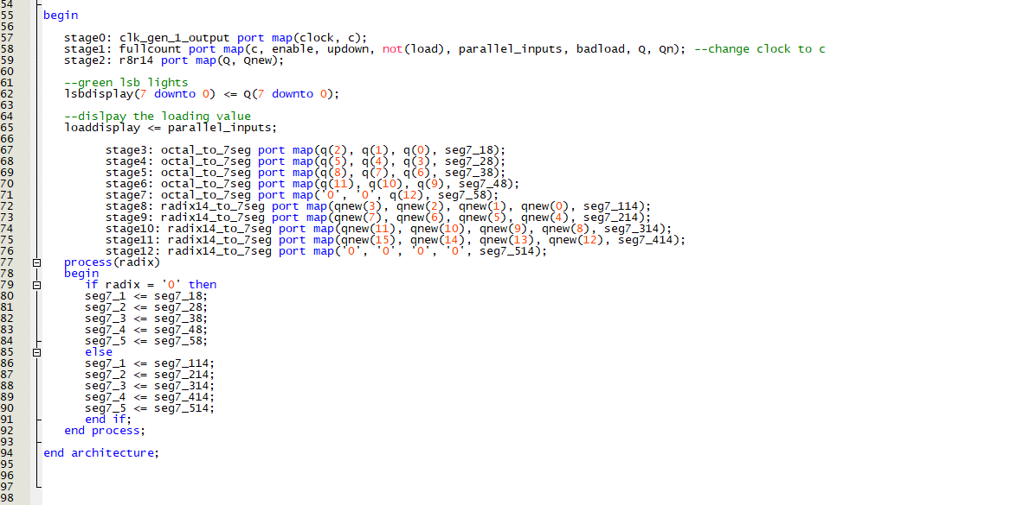
The top level was used to tie all files together as a whole. The top level has a full counter, a radix 8 to radix 14 converter, 2 seven segment converters, one for each radix, and a clock controller as well.

Instantiated Code:
Fullcount.vhd :
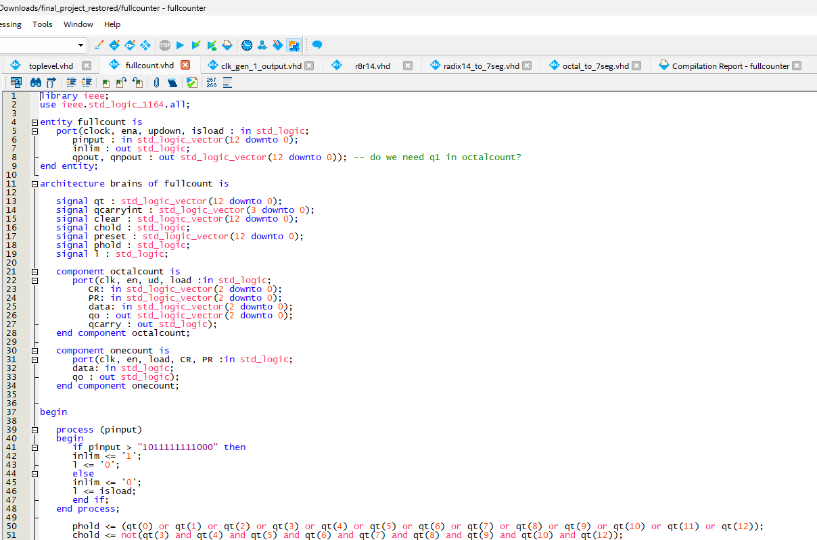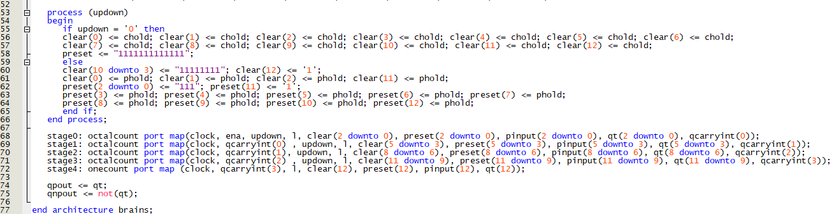
This is the full counter, which takes the octal counter and one bit counter as components. This allows for counting in radix 8, with the 4 octal counters counting the first 12 bits, and the one counter counts the 13th bit. This file also contains the input for the load value as well.

R8r14.vhd:
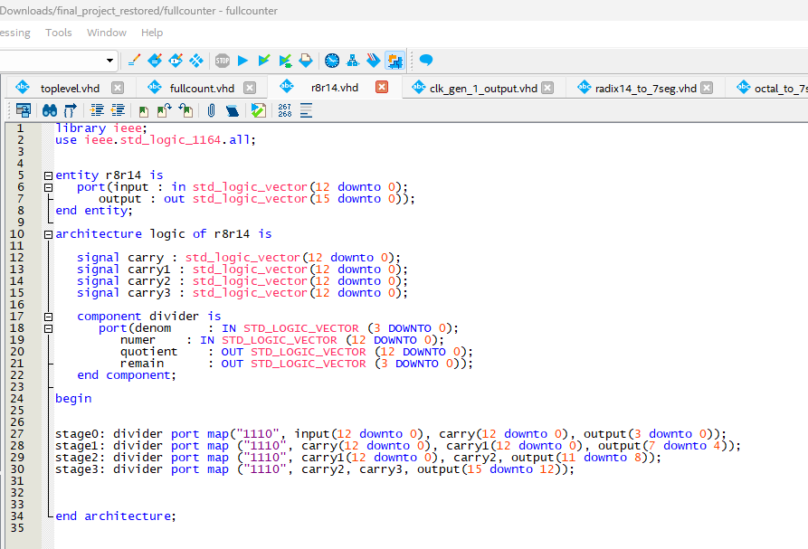
This file converts from radix 8, which is the counting radix, to radix 14, which is the alternate radix to output as. It uses a divider as a component, which is a library used to facilitate the conversion.

Octal_to_7seg.vhd:
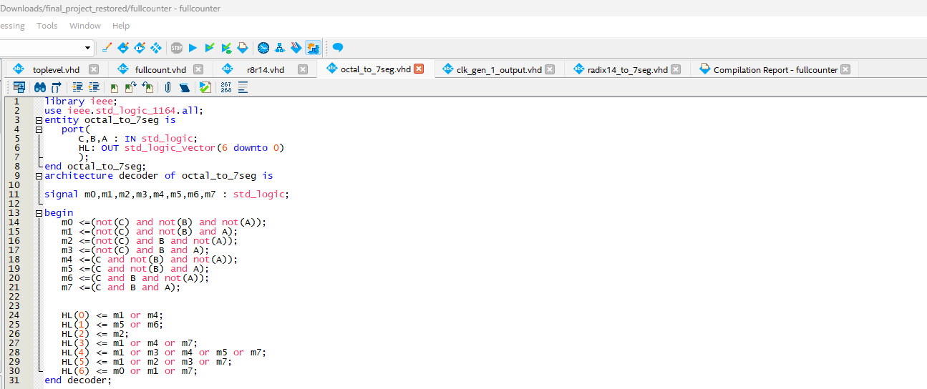
This is the code that converts each octal value into an output suitable to provide to a seven-segment display, allowing us to display the value that we are currently counting at.
Radix14_to_7seg.vhd: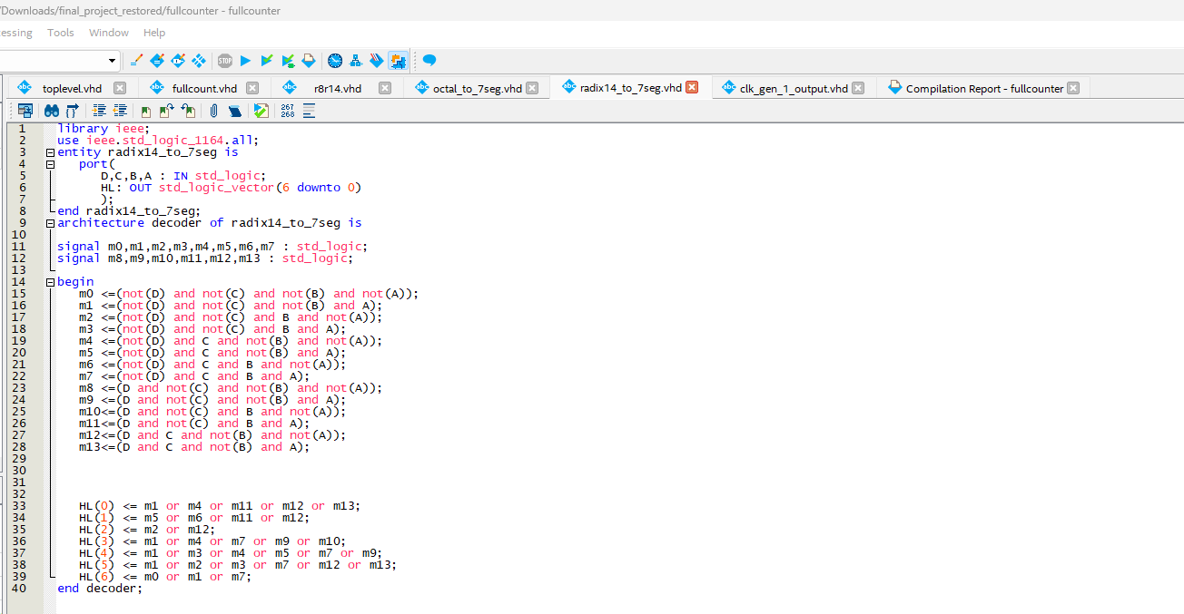
This is the code that converts each Radix-14 value into an output suitable to provide to a seven-segment display, allowing us to display the value that we are currently counting at.

Clk_gen_1_output.vhd:
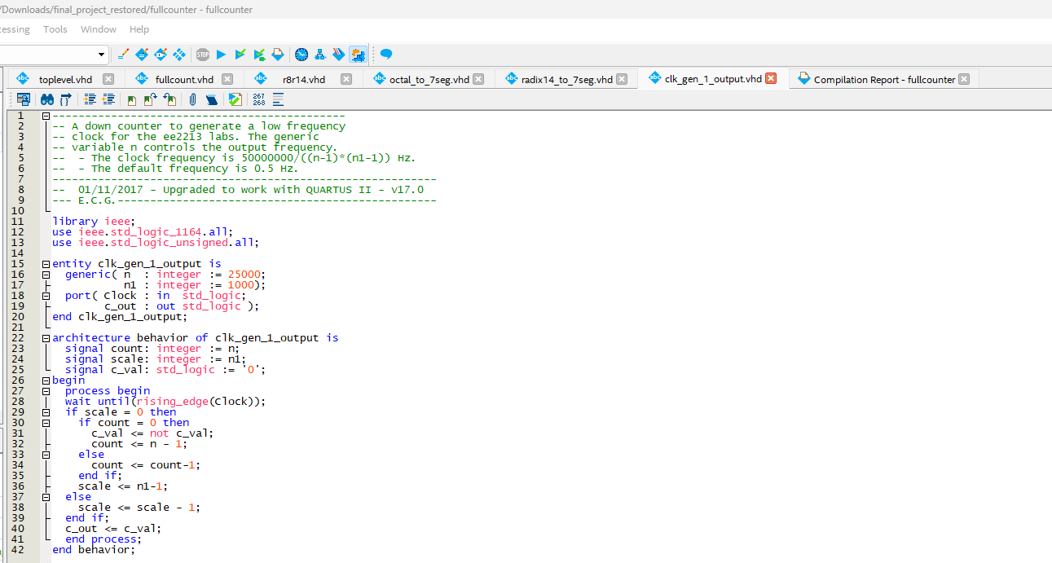
This is the clock controller; it scales the timing on the clock so that it ticks at a slower rate making it much easier to observe the function of the counter.

Results
In these simulations a variable full count was added which shows all bits and the output from clk_gen_output was ignored.
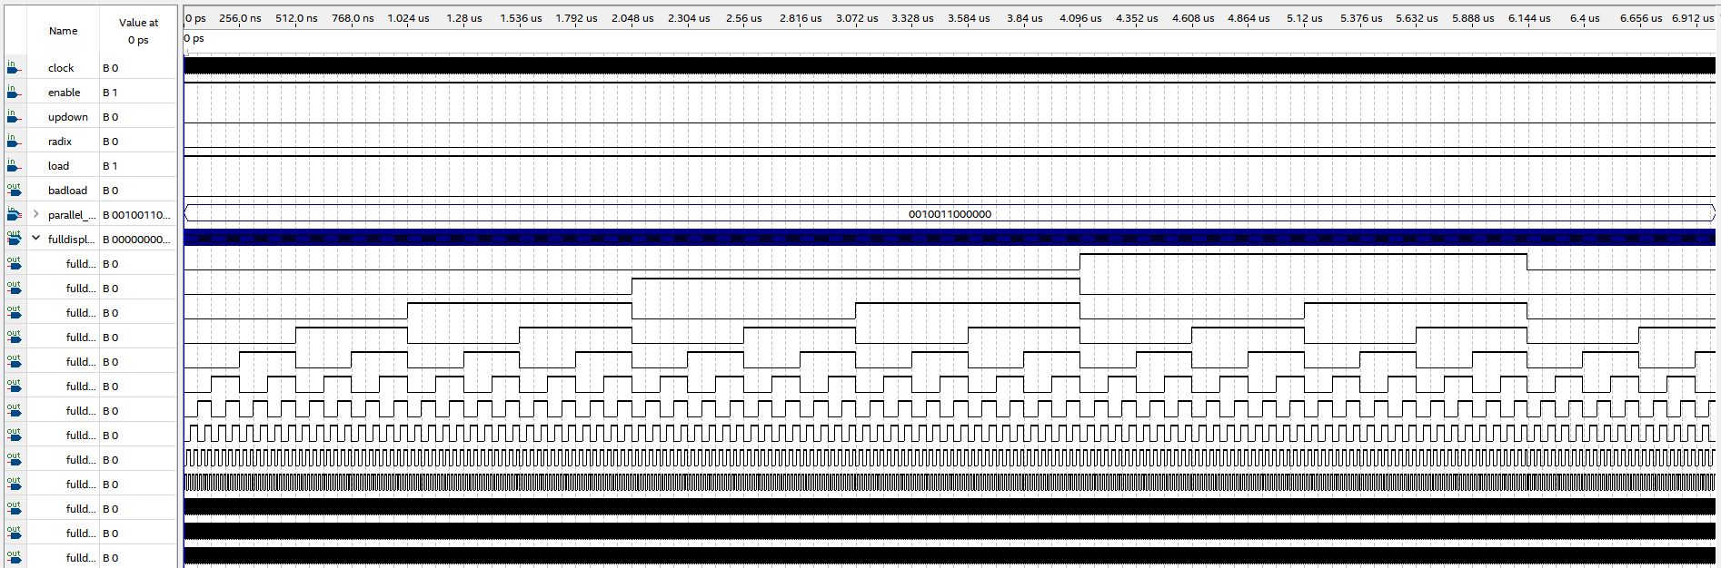This simulation shows the circuit counting up to its highest value resetting to 0.

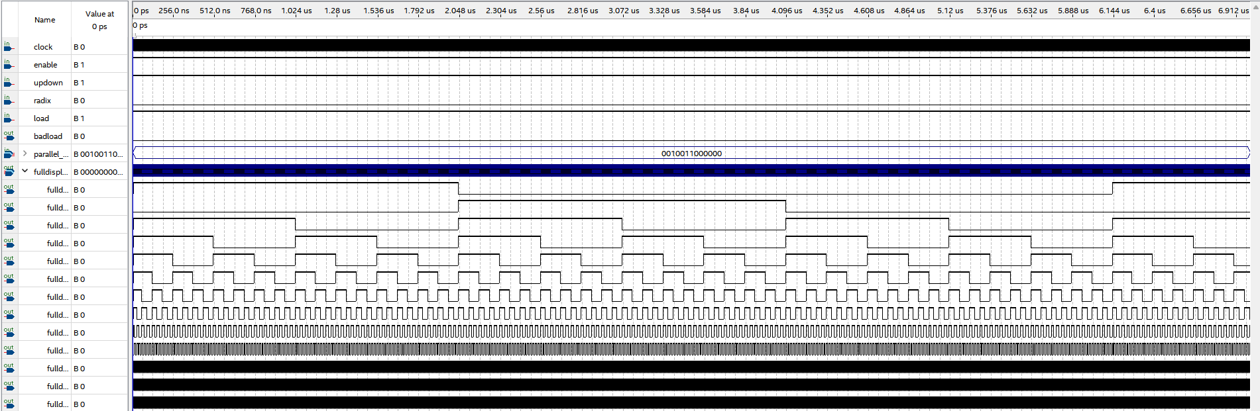This simulation shows the circuit counting down to its lowest value resetting to the highest value.
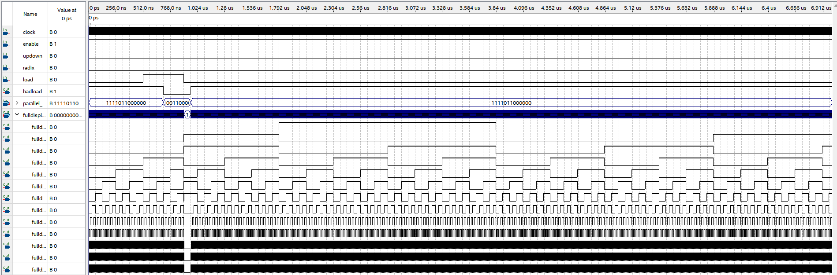This simulation shows the circuit counting up with a load. The load is ignored at first because the input is too high, shown in the variable badinput, then the active low load is set high, so it ignores it again before finally being set low and receiving an acceptable value which it loads on the circuit.
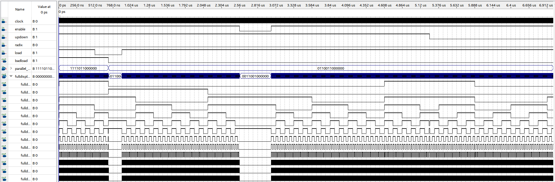This simulation starts in down count mode, then receives a load value before continuing to count down. Then enable is turned off which keeps the values but stops the system from counting. Lastly the mode is changed to up counting which it keeps until the end.

Timing simulations for above cases
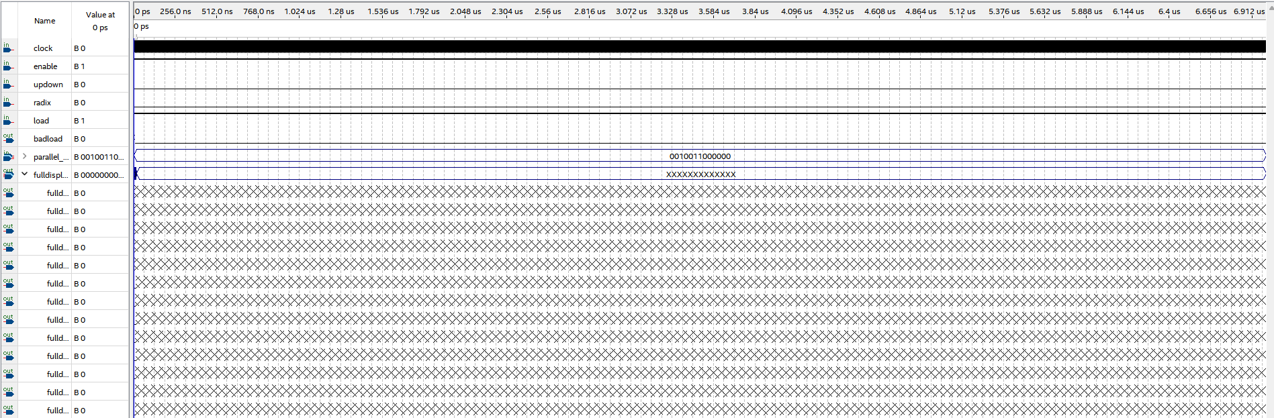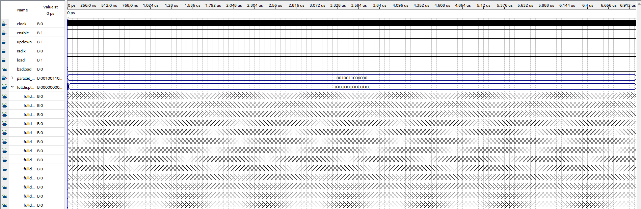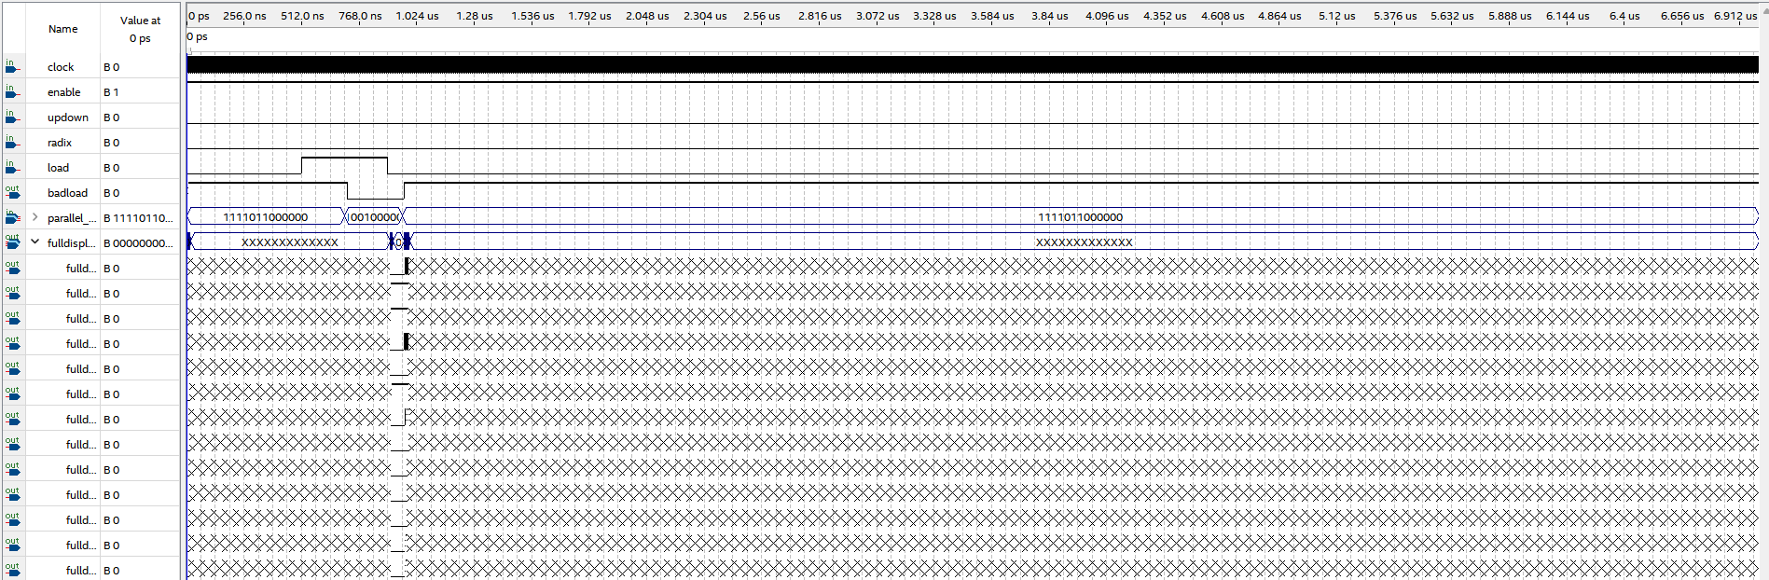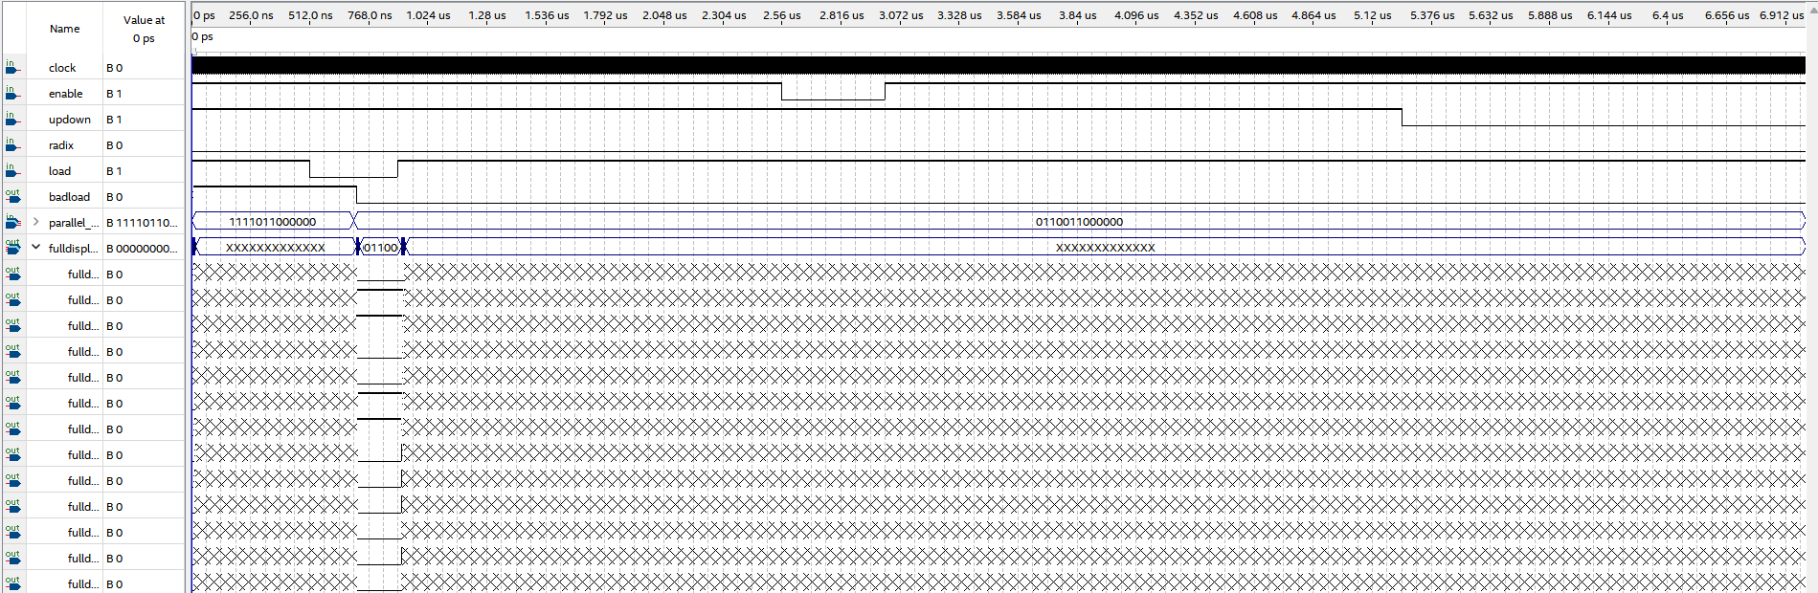
Everything in all simulations worked as expected.

Conclusion
This project required many VHDL files to be instantiated throughout and proved to be good practice using Quartus prime and instantiating files within files, creating a complex structure to perform a task more difficult than in a normal lab environment. This project also challenged us to work in a team larger than normal, which proved to be a great experience as well, since we were able to work as a team to tackle this larger problem.
Test Plan
- Display start/stop functionality of counter
  - Show that the counter will activate when the activation switch is toggled high
- Display the ability to swap between up and down counting
  - Show that the output can be swapped between an up counter and a down counter, with low up and high down
- Display the functionality to swap between radix 8 and radix 14
  - Show that the output radix can be toggled with radix 8 as low, and radix 14 as high
- Display functionality of 8 green LED’s which displays the 8 lsb’s
  - Show that the 8 green LED’s will show the 8 lsb’s of the value being counted
- Display functionality of 13 red LED’s which display the load value, which is loaded via 13 load switches and a load push button
  - Show that the red LED’s will display the load value that is represented by the 13 load input switches, which are all switches on the board
- Display functionality red LED which lights up if the load value on switches is too high
  - Enter a value that is too high and try to load it
- Display functionality of 7 segment display, which will display in the selected radix
  - Show that the current count value will be displayed on the 7-segment display

